# K8S Static Analysis Definition File

Catch the security-related issues or enforce standards before it is deployed to the cluster even before the user runs kubectl command.

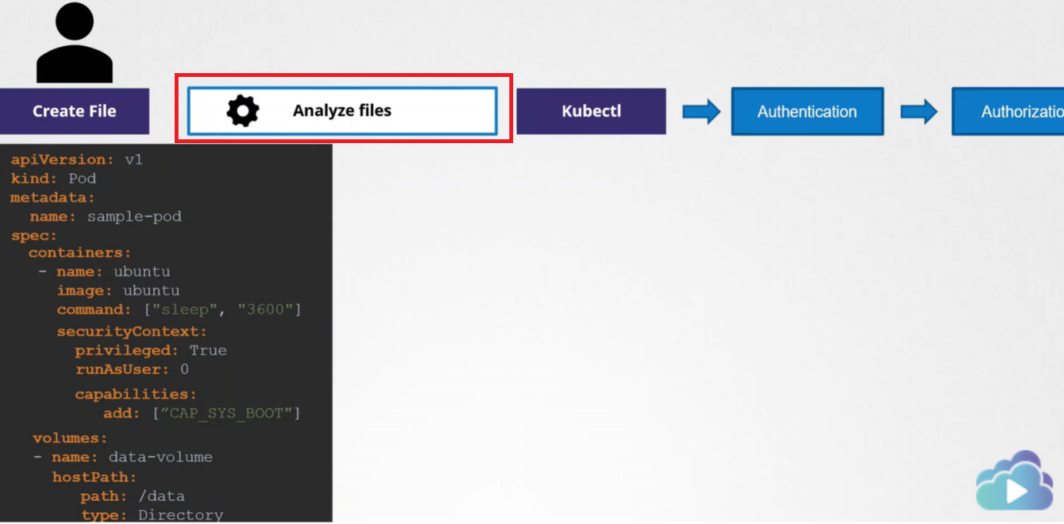

Tools: kubesec

<https://kubesec.io/>

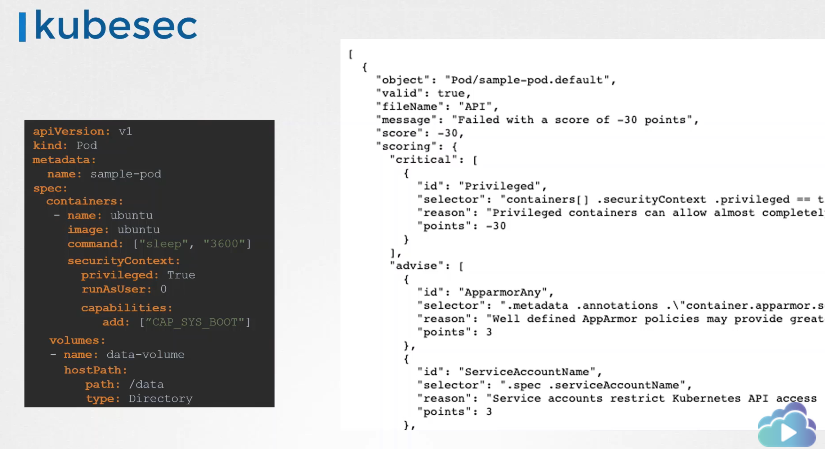

Kubesec helps analyze a given resource definition file and returns its score along with details about the critical issues that were found it.

Deploy kubesec:

https://github.com/controlplaneio/kubectl-kubesec

